*Train Simulation*

Use Case Specification Document

**Case Id 6**

**Run Simulation**

Version No. 2.0.0

Project Document Revision History

|  |  |  |  |
| --- | --- | --- | --- |
| **Version Number** | **Date** | **Revision Author** | **Description of Revision** |
| 1.0.0 | 3/14/19 | Alex Navarre | Initial Version |
| 2.0.0 | 4/19/2019 | Zaid Alsafi | Remove any assumption |

Table of Contents

**1. Introduction** **3**

**2. Use Case Information** **4**

2.1 Actors 4

2.2 Use Case Interaction 5

**3. Trigger** **5**

**4. Pre-condition(s)** **6**

**5. Post-Condition(s)** **6**

**6. Use Case Swimlane Diagram** **7**

**7. Main/Basic Flow(s) of Events** **8**

**8. Alternative/Exception Flow of Events** **8**

**9. Assumptions/Business Rules including Non-Functional Requirements** **8**

# 1. Introduction

The user will be given ~~two~~ opportunities to run their simulation: after they have imported their initial data from files to set up the initial graph and after they have made any changes to the simulation. The simulation will run according to the parameters set by the user and the simulation systems graph creation. It will be affected by the weather severity ~~and~~  as well as addition or removal of trains, tracks, stations, and hubs. The data will then be stored and made available to the user after each run of the simulation.

# 2. Use Case Information

## 2.1 Actors

|  |  |  |
| --- | --- | --- |
| **Actor Name** | **Role** | **Description** |
| User | Main Actor | The user will provide the data to create the initial graph creation and simulation settings. They will also interact with the UI to make changes to the simulation and view information. |
| Simulation System | Main Actor | The simulation system will handle the graph creation, simulation editing, and running the simulation. It contains the logic that is used to perform each simulation run according the user’s choices. |
| Weather System | Main Actor | The weather system controls the train stop delays based on severity of weather that is chosen by the user. This will directly affect the simulation system. |
| Maintenance System | Main Actor | This system controls the maintenance schedule provided by the user. This will also directly affect the simulation system and its operation. |

## 

## 2.2 Use Case Interaction

A list of predecessors use cases are as follows:

Use Case 1 – Setup Initial State: In order to run a simulation, the user must ~~setup~~ set up their initial system by importing their own graph data.

Use Case 2 – Add/Remove Trains: Addition or removal of trains will affect the way that the simulation will run.

Use Case 3 – Edit Railway: Addition or removal of stations, hubs, and individual edges will affect the way that the simulation will run.

Use Case 4 – Adjust Weather: Addition, removal, or severity change of the weather will affect the way the simulation will run.

Use Case 5 – Update Graph: Application of user changes between simulation runs will create a new simulation graph.

A list of successors use cases are as follows:

Use Case 7 – Track Statistics: Running of the simulation generates data for the user.

Use Case 8 – Recommend Changes: This is the act of collecting and recording important information that can be used for the suggestion system to make decisions.

Use Case 9 – View Statistics: Viewing of the suggested changes file will be a part of viewing the overall statistics

Use case 10 – Rollback Simulation History: This is the final step in the program, it logically comes after all other use cases.

# 3. Trigger

The use case is triggered after the user imports their own data and the initial graph is created. There will be a final check before the first simulation run will be attempted. After each run has been completed, the user will have the option to make changes and/or continue running the simulation. Before each run, the simulation system will have to gather information from the weather and maintenance systems in order to correctly carry out operation.

# 

# 4. Pre-condition(s)

4.1 User imports data and initial graph has been created

4.2 User edits simulation graph and chooses to run another simulation

4.3 Weather system is engaged, or the severity is changed

# 5. Post-Condition(s)

5.1 After each simulation run, the user is shown the collected data and statistics

5.2 The user will also be promoted to view the file including the suggested changes

5.3 The user will be asked if they wish to re-run the simulation

# 6. Use Case Swimlane Diagram

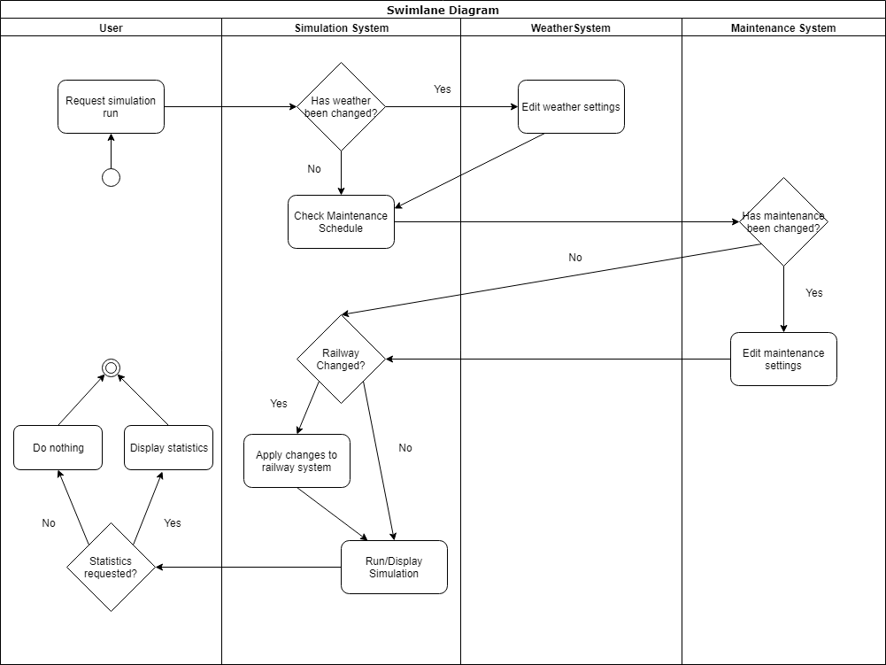

# 

# 7. Main/Basic Flow(s) of Events

7.1 A user will import their files to create initial system will be created that will be ran.

7.2 The simulation will not be changed and then the simulation will be run again.

7.3 Train tracks will be added or deleted, and the simulation will be run again.

7.4 Stations/hubs will be added or deleted, and simulation will be run again.

7.5 Trains will be added or deleted, and the simulation will be run again.

7.6 Weather will be added or adjusted, and the simulation will be run again.

7.7 Important data and statistics will be collected and stored.

# 8. Alternative/Exception Flow of Events

8.1 User could attempt to import invalid files, error message will be displayed

8.2 Out of bounds edge lengths could be assigned to tracks, system will display error message.

# 9. Assumptions/Business Rules including Non-Functional Requirements

9.1 The initial simulation will always be run without user changes applied.

~~9.2 Simulation runtime will not exceed 5 seconds.~~

~~9.3 All changes being applied to the simulation system will not exceed 5 seconds.~~

9.4 The simulation will provide the user with useful data and options for data modeling.